FRAMEWORK FOR LIVE DIGITAL FORENSICS USING DATA MINING

ABSTRACT:
With the rapid advancements in information and communication technology in the world, crimes committed are becoming technically intensive. When crimes committed use digital devices, forensic examiners have to adopt practical frameworks and methods to recover data for analysis which can pose as evidence. This concept explains emerging cyber crimes, forensic analysis steps in the storage media, hidden data analysis in the file system, network forensic methods, Memory Forensic Modules and cyber crime data mining. This paper introduces the K-Means and Apriori algorithm for finding the cyber attack and the counting of the attacks during the system working time. For this purpose, system uses the tools of Wincap, jpcap and wmic. This tool combines the technique of digital forensic investigation and crime data mining. Thus this tool provides the defense and reduces the vulnerability.

INTRODUCTION:
Traditional information security research focuses on defending systems against attacks before they happen. Although recent intrusion detection systems can recognize and take against attacks, comparatively little research focuses on after-the-fact investigation. This is, in part, because network owners are more willing to absorb losses from computer crime that risk their reputations by letting details of their exploited vulnerabilities become public. More number of cyber attacks is possible in the systems. Those are hacking, Dos attack, DDoS attacks, Software Piracy attacks, Pornography attacks, Spoofing attack, Virus attack, Threatening attacks, Phishing attacks, Salami attack, Zeroday attack and war driving attack. This cyber attacks are mostly identified by the digital forensic investigation.
Digital forensics has existed for as long as computers have stored data that could be used as evidence. For many years, digital forensics was performed primarily by government agencies, but has become common in the commercial sector over the past several years. Originally, much of the analysis software was custom and proprietary and eventually specialized analysis software was made available for both the private and public sectors. Recently, open source alternatives have been developed that provide comparable features.
In general, the goal of digital forensic analysis is to identify digital evidence for an investigation. An investigation typically uses both physical and digital evidence with the scientific method to draw conclusions. Examples of investigations that use digital forensics include computer intrusion, unauthorized use of corporate computers, child pornography, and any physical crime whose suspect had a computer.
To see the challenges faced by the next generation of digital forensics tools, we examine the looming problems of scale that will soon overwhelm current generation tools. The primary challenges are fueled by fundamental trends in computing and communication technologies that will persist for the foreseeable future. Storage capacity and bandwidth available to consumers are growing extremely rapidly, while unit prices are dropping dramatically. Coupled with the consumer’s urge to have everything online, where music collections, movies, and photographs will increasingly be stored solely in digital form, these trends will result in even consumer-grade computers having huge amounts of storage. From a forensics perspective, this translates into rapid growth of the number and size of potential investigative targets. To be ready, forensic professionals need to scale up both their machine and human resources accordingly.
A digital forensic investigation is an inquiry into the unfamiliar or questionable activities in the Cyber space or digital world. The File system investigation is the identification, collection and analysis of the evidence from the storage media. File systems or file management systems is a part of operating system which organize and locate sectors for file storage.
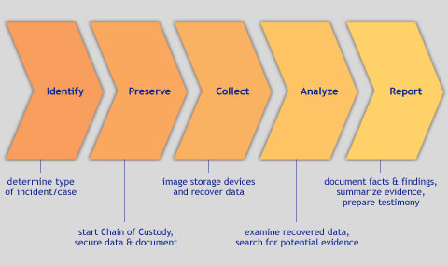
Fig.1 Digital Forensic Tool
Digital Forensics is the recovery of data from any type of digital device or media that is retrievable through professional analysis, scientific processes and methodogies that can be validated and potentially utilized in a court of law as evidence. Forensic Analysis is the use of controlled and documented analytical and investigative techniques to identify, collect, examine, and preserve digital information. Recognizing the fragile nature of digital data, and the legal and regulatory requirements to properly preserve electronically stored information during forensic investigations, Secure State maintains standards relating to protecting electronically stored information against manipulation or destruction.
Traditional forensic tools gather evidence from persistent storage devices such as hard drives. In contrast, newer forensic tools also collect ephemeral evidence from the memory of a running computer. Tools such as Volatility deconstruct and decipher the raw memory dumps and search for evidence of interest. While these tools can find evidence such as the process list, open network sockets and open files, which are directly related to the running system, they are often unable to provide deep semantic insight into the internal operations of the running programs. Without the use of time-consuming manual analysis or speciﬁcally developed tools, the forensic investigator cannot temporarily access or decipher all of the relevant evidence.
Forensic analysis is the use of controlled and documented analytical and investigative techniques to identify, collect, examine and preserve digital information. SecureState provides a thorough approach to the forensic methodology, and ensures all tools; methodologies and processes are forensically sound and unaltered. SecureState works as an extension of the corporation’s response team to help ensure relevant and efficient analysis for three primary areas of forensics: Evidence Acquisition, Evidence Analysis, and Evidence Reporting.
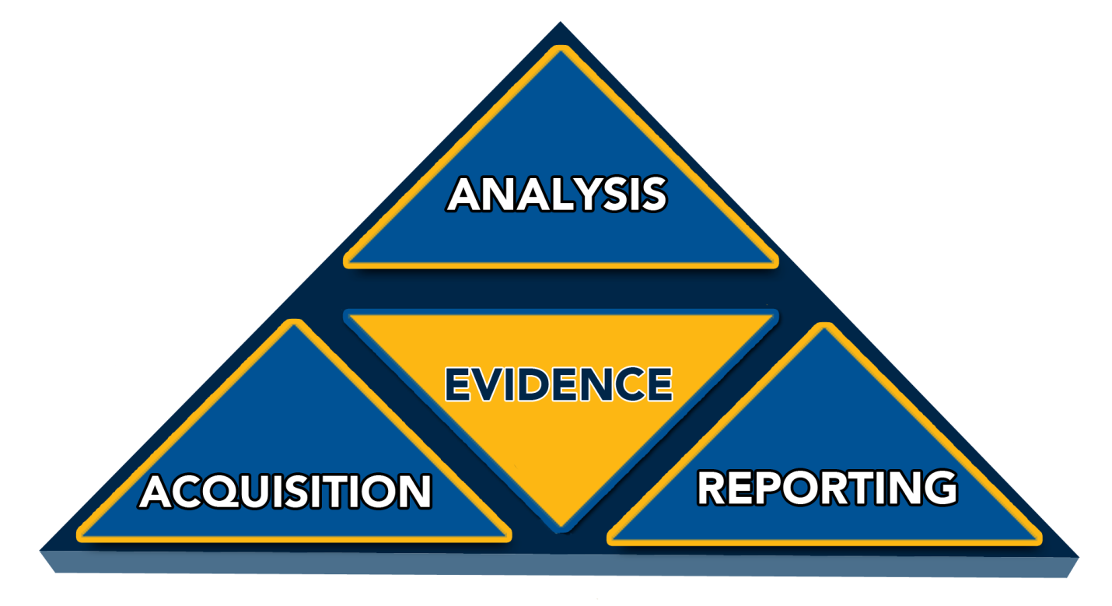
Fig. 2 digital forensic
Forensic Acquisition: Computer Forensics Acquisition is the process of acquiring electronic evidence in a manner that preserves the data and maintains chain of custody. SecureState establishes tested and proven acquisition methodologies, information gathering and structured reporting of security related events. Electronic evidence contains the information needed to understand how the events happened, resources or data that may have been affected, and mitigation strategies. It is essential that electronic evidence is acquired in a methodical, safe, and secure manner.

Evidence Collection: All evidence collection procedures are reviewed by SecureState’s Incident Response Team before acquisition begins. As deemed appropriate, SecureState is the custodian of data and the handler for response, evidence collection and retention, and data or device analysis. All imaging, data collection and documentation will be observed and supervised by a SecureState Lead Investigator.

Forensic Analysis: The primary scope for Forensic analysis is to identify unauthorized or anomalous indicators that exist (past or present), how they were deployed, and what capabilities they might have had on the system. After identifying if a successful compromise or malicious software exists, SecureState’s primary focus would be directed at determining applicable next steps relating to regulatory or legal compliance, as well as business impact and risk. Applicable next steps would involve additional forensic acquisition and documentation, collecting and identifying the initial intent of the compromise, remediation, and determining if any private, regulatory or sensitive data was captured or modified.

Documenting and Recording: All details, facts and processes will be documented as soon as the Response Team begins analysis on a potential incident or forensic investigation. SecureState will incorporate appropriate media for logging the incident process such as host records, tagging and labeling systems. Every step taken from the time the incident was detected and recorded to its resolution will be documented, time stamped, reviewed, and signed by the incident handler. Since documentation is an ongoing process throughout the examination, it is vital to be complete, accurate, and comprehensive during the reporting process. SecureState will safeguard data related to incidents since it will contain sensitive system or personnel information, data on exploited vulnerabilities, or information that may be needed for law enforcement. To reduce the risk of sensitive information being disclosed, SecureState ensures that access to incident data is restricted and properly stored. In accordance with applicable policies, rules, regulation, or other governing requirements, SecureState is responsible for the secure and timely delivery of its investigation reports, final incident reports, and all other reports required in accordance with the Incident Response Policies.

When an incident occurs, the Incident Response Team may deem it necessary to perform a forensic investigation based upon legal, financial or regulatory requirements. The purpose of forensics is to determine actions, motives, vectors, effects, and evidence for incidents, misuse, theft, or fraudulent activities.
Here system performs three types of analyzers. These are Network forensic analyzer, file analyzer and memory forensic analyzer. Network forensic analyzer is the process of network traffic analyzer. Network traffic analyzer is performed by network monitoring. A network analyzer is a computer program or a piece of computer hardware that can intercept and log traffic passing over a digital network or part of a network. As data streams flow across the network, the sniffer captures each packet and, if needed, decodes the packet's raw data, showing the values of various fields in the packet, and analyzes its content according to the appropriate RFC or other specifications. For monitor this process here we use the jpcap tool. This jpcap tool monitors the networking details of the system. This jpcap tool monitors the traffic and displays the details like Source Mac, Destination Mac, Source IP, Destination IP and Captured Time. Then this data is stored as thumb data in the system. This thumb data is given to the input as the crime detection process. This crime detection process is detecting the attacks which are finding in the whole data.
Next module is the file analyzer module. This file analyzer module is the process of analyze the file details. When system receive any other file from another system, here this file analyzer first monitor the receiving data, and analyze the modifying of this files and analyze the deletion of this file. This all analyzing data is then provided to the crime data mining. Here system identify the crime occurs in the system.
Finally we perform the memory forensic modules. In these memory forensic modules, System goes to use the wmic tool. From this tool it detect the what are the process running in the system, what are the ports opened in the system, list out what are the services running in the system, which system has booted up till that moment and Finally login session details of the users. Then this result also moves to the crime data mining. Here it detects what are the attacks occurred in the system.
These all the attacks and cyber crime are detect by using the crime data mining process. Cyber Crime Data mining is the extraction of Computer crime related data to determine crime patterns. With the growing sizes of databases, law enforcement and intelligence agencies face the challenge of analyzing large volumes of data involved in criminal and terrorist activities. Thus, a suitable scientific method for digital forensics is data mining. This crime data mining is working under the algorithm of k-mean and apriori algorithm. Finally we show the results and graph for the system prediction.
SCOPE OF THE PROJECT:

Main scope of the project is to analyze the different types of packets ICMP, TCP and UDP from the network forensic modules. Analyze the Process (lists all processes running on the system), Port (list of all port used in the system), Services (list out the services running on system), Load order (gives order in which system has booted up till that moment) and Netlogin (gives login session details of the users) from the memory forensic modules. Analyze the evidence from the deleted files from the file system analyzer. This process is Predicted by the crime data mining. This crime data mining is performed by the K-means algorithm, Apriori algorithm.

PROBLEM DEFINITION:
- More number of cyber attacks are done in the system that are, hacking, Dos, DDos, spoofing, Virus, Threatening, Phishing, Salami attacks, War Driving and Pornography.
- These all attacks are find out by the basic investigation technique and Network attacks techniques.
This sometimes provides the false information. So we provide the new technique in our paper

EXISTING SYSTEM:
Existing system has the more technique to identify the attacks that are, RAM Forensics, in memory forensics and Anti forensics tools. All this process provides the good results. All based on the volatile memory and acquisitions process. And this system is based on the investigation and network analysis process. In memory forensics contains processes. There are current running processes and terminating processes, open TCP/UDP ports, memory mapped files, caches etc. In anti forensics tool system calls the remote server. This method is focus on the data contraception. All the evidences are collected from the anti forensics tool. Anti forensics tool analysis and collect the details from the system and provides the results to the users.

DISADVANTAGES:
- Difficult to predict the attackers involved in the network.
- Existing methods are not efficient to provide good results.
- Remote server can have lots of storage space.
- Need more investigation regarding to the digital forensic tool.
- Volatile memory does not perform well.

NEED FOR NEW SYSTEM:
- All the existing system provides the good results.
- But we need the system to predict from the attacks.
- So we move to the new system.

PROPOSED SYSTEM:
Proposed work we provide the technique of digital forensic tool to predict the attacks. To provide the excellent results, here system introduces the three types of the evidence collection method, investigation method and prediction method. Evidence based on the live forensic attacks. These systems introduce the hidden evidence acquisition from file system. Evidence collection and Investigation is based on three types of processes. Those are Network Forensic modules, File forensic modules and Memory forensic modules. And this process is predicted by the crime data mining. Those use the algorithms of K-means and apriori algorithm. Our proposed model is the combination of digital forensics and data mining. Our proposed system helps to increase the security of the organization. When an incident reported, it investigates and report is saved in the database. Using crime data mining tool the nature of the attack is identified and alert administrator about similar attacks in future. Proactive measures can be initiated to prevent future cyber attacks.

ADVANTAGES:
- Effective prediction technique
- Easy to perform.

SYSTEM REQUIREMENTS

SOFTWARE REQUIREMENTS:
OPERATING SYSTEM : WINDOWS 7 (32 bit system)
FRONT END : JAVA
IDE : NETBEANS 6.9.1
TOOL SOFTWARE : WINCAP, JPCAP

HARDWARE REQUIREMENTS:
PROCESSOR : PENTIUM III & ABOVE
RAM : 256MB
HARD DISK : 40GB

MODULES

LIST OF MODULES:

- Network Forensics Analysis
- File Forensic Analysis
- Memory Forensic Analysis
- Crime Data Mining

MODULES DESCRIPTION

NETWORK FORENSICS ANALYSIS:

The growing popularity of the Internet in homes means that computing has become network-centric and data is now available outside of disk-based digital evidence. Network forensics can be performed as a standalone investigation or alongside a computer forensics analysis. Network forensic module is equipped with a traffic monitoring tool for data/evidence collection. A packet analyzer provides live forensic information about an attack. For monitor this process here system use the jpcap tool. This jpcap tool monitors the networking details of the system. This network forensic module consist of Source MAC, Destination MAC, Source IP, Destination IP, Captured Time, Method, Protocol, Captured Length, Frame Type, Version and Destination Host. After completed this process, select the project folder and save the file.

FILE FORENSIC ANALYSIS:

File system Analyzer module finding the evidence from the deleted files, free spaces. This process shows all the directories and files which are present in the particular drive. Then identify what are the files deleted in the system. This tool Collects evidence from the file system, searches data in the free space, slack spaces and deleted spaces. For free spaces detection, system identifies the details of used size, free size and Total size.

MEMORY FORENSIC ANALYSIS:
Memory Forensic Analysis process consist of the browser history and active process in the system. This process consists of Process (lists all processes running on system), Port (list all ports in the system), Services (list out services running on system); Load order (gives order in which system has booted up till that moment), and Net login (gives login session details of the users). For this purpose we use the wmic tool.

CRIME DATAMINING:
For crime data mining, system uses the algorithms of K-means and Apriori algorithms. Process of K-means algorithm is collects the training set. After that it collect the test set. Then generate K value. After the k value generation it calculates the similarity between the training set and test set. Then it makes the clustering process, and finally it show prediction results. Process of Apriori algorithm is collection of training set and test set. Then compare test set with training set. Then identify the frequent item set. Then apply association rule. Finally it shows prediction results.

DATAFLOW DIAGRAM

Live forensic information

Evidence collection from the deleted files and free spaces
Memory Forensic Analysis
PREDICTION
Network Forensic Analysis
File Forensic Analysis
CRIME DATAMINING

K MEANS ALGORITHM
APRIORI ALGORITHM

SYSTEM ARCHITECTURE

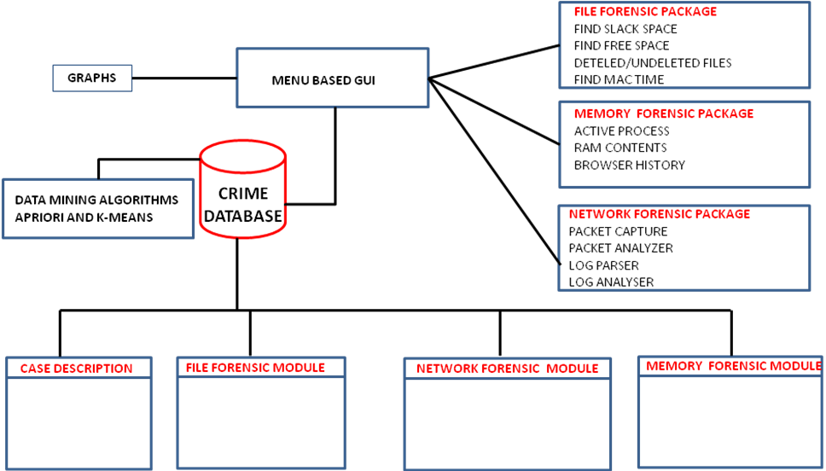
Case ID Case Description Login Details System Specification
File Path File Name Created Time Free Size Total Size
Source IP Address Destination IP Address MAC address Captured Length
Process Port Services Load order Net Login

UML DIAGRAMS

UML stands for Unified Modeling Language. It represents a unification of the concepts and notations presented by the three amigos in their respective books. The goal is for UML to become a common language for creating models of object oriented computer software. In its current form UML is comprised of two major components: a Meta-model and a notation. In the future, some form of method or process may also be added to; or associated with, UML. UML is unique in that it has a standard data representation. This representation is called the Meta model. The meta-model is a description of UML in UML.

It describes the objects, attributes, and relationships necessary to represent the concepts of UML within a software application. This provides CASE manufacturers with a standard and unambiguous way to represent UML models. Hopefully it will allow for easy transport of UML models between tools. It may also make it easier to write ancillary tools for browsing, summarizing, and modifying UML models. A deeper discussion of the Meta model is beyond the scope of this column. Interested readers can learn more about it by downloading the UML documents from the rational web site. The UML notation is rich and full bodied.

It is comprised of two major subdivisions. There is a notation for modeling the static elements of a design such as classes, attributes, and relationships. There is also a notation for modeling the dynamic elements of a design such as objects, messages, and finite state machines.

USECASE DIAGRAM:
Use case diagrams model the functionality of a system using actors and use cases. Use cases are services or functions provided by the system to its users. The purpose of use case diagram is to capture the dynamic aspect of a system. But this definition is too generic to describe the purpose. Because other four diagrams (activity, sequence, collaboration and State chart) are also having the same purpose. So we will look into some specific purpose which will distinguish it from other four diagrams.

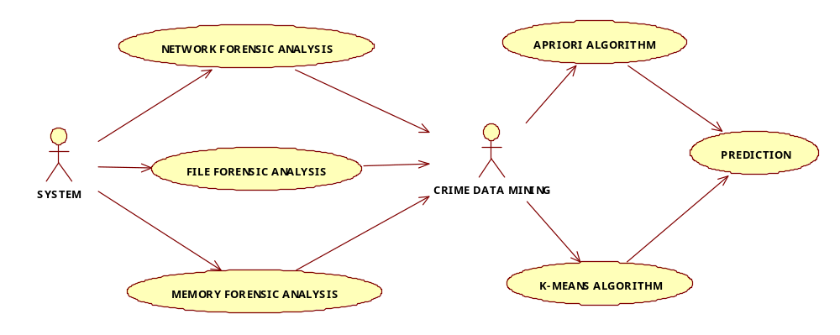

CLASS DIAGRAM:
The class diagram is a static diagram. It represents the static view of an application. Class diagram is not only used for visualizing, describing and documenting different aspects of a system but also for constructing executable code of the software application. The class diagram describes the attributes and operations of a class and also the constraints imposed on the system. The class diagrams are widely used in the modeling of object oriented systems because they are the only UML diagrams which can be mapped directly with object oriented languages. The class diagram shows a collection of classes, interfaces, associations, collaborations and constraints. It is also known as a structural diagram.

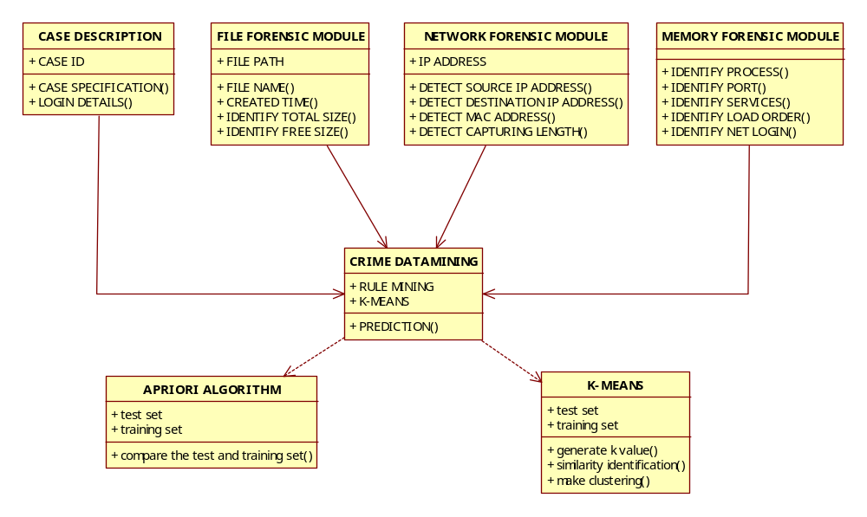

SEQUENCE DIAGRAM:
Sequence diagrams describe interactions among classes in terms of an exchange of messages over time. UML sequence diagrams are used to show how objects interact in a given situation. An important characteristic of a sequence diagram is that time passes from top to bottom: the interaction starts near the top of the diagram and ends at the bottom (i.e. Lower equals later). A popular use for them is to document the dynamics in an object-oriented system. For each key collaboration, diagrams are created that show how objects interact in various representative scenarios for that collaboration.

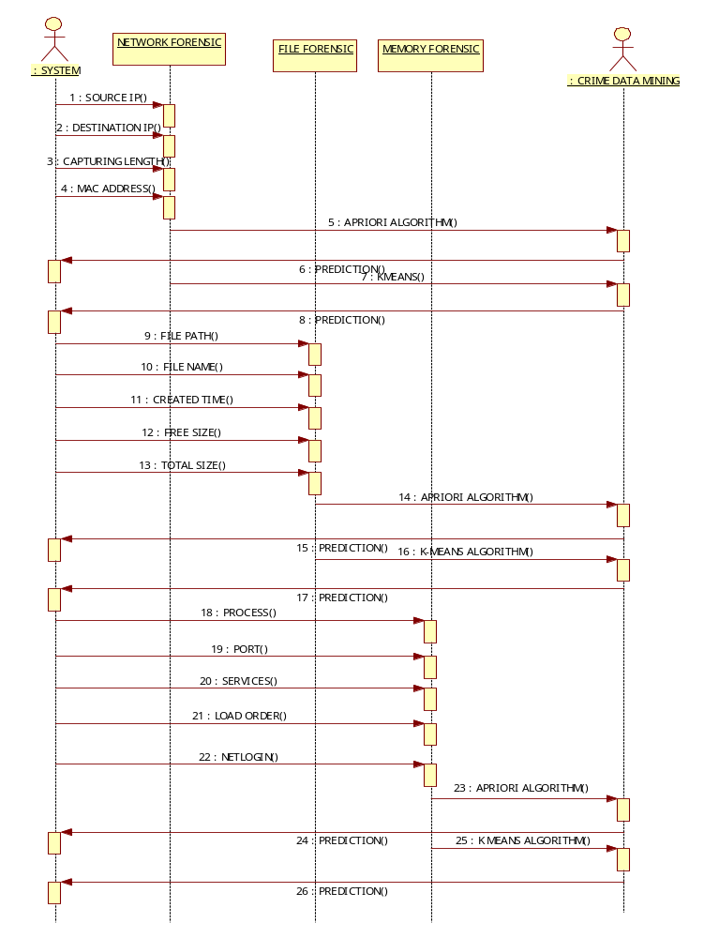

COLLABORATION DIAGRAM

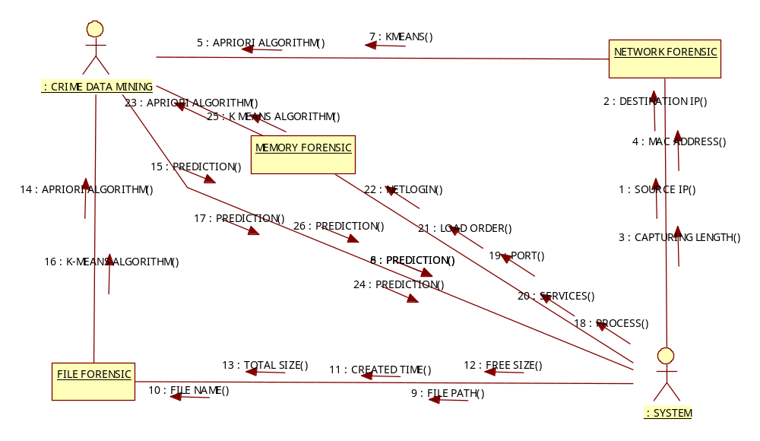

ACTIVITY DIAGRAM
Activity diagrams are graphical representations of workflows of stepwise activities and actions with support for choice, iteration and concurrency. In the Unified Modeling Language, activity diagrams can be used to describe the business and operational step-by-step workflows of components in a system. An activity diagram shows the overall flow of control. Activity diagram is another important diagram in UML to describe dynamic aspects of the system. Activity diagram is basically a flow chart to represent the flow form one activity to another activity. The activity can be described as an operation of the system. So the control flow is drawn from one operation to another. This flow can be sequential, branched or concurrent. Activity diagrams deals with all type of flow control by using different elements like fork, join etc.
The basic purposes of activity diagrams are similar to other four diagrams. It captures the dynamic behavior of the system. Other four diagrams are used to show the message flow from one object to another but activity diagram is used to show message flow from one activity to another. Activity is a particular operation of the system. Activity diagrams are not only used for visualizing dynamic nature of a system but they are also used to construct the executable system by using forward and reverse engineering techniques. The only missing thing in activity diagram is the message part. It does not show any message flow from one activity to another. Activity diagram is some time considered as the flow chart. Although the diagrams looks like a flow chart but it is not. It shows different flow like parallel, branched, concurrent and single.
So the purposes can be described as:
- Draw the activity flow of a system.
- Describe the sequence from one activity to another.
- Describe the parallel, branched and concurrent flow of the system.

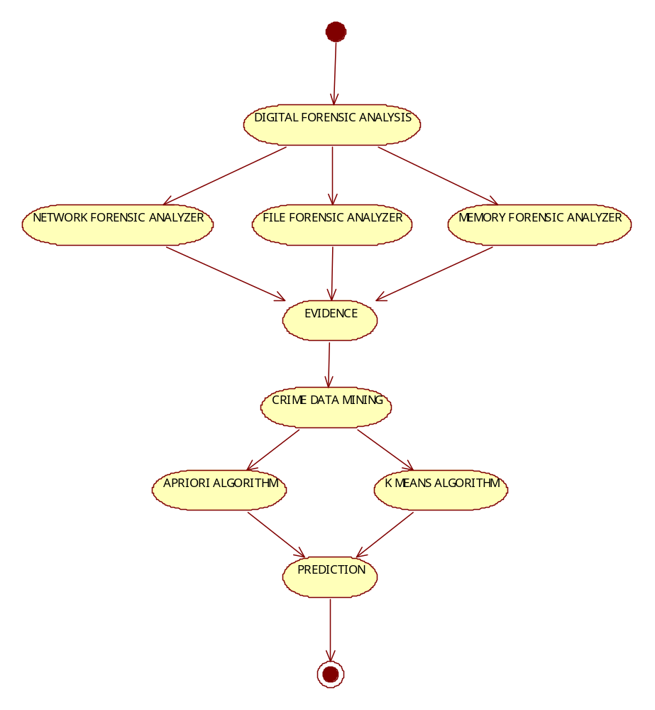

LITERATURE REVIEW:
- Natarajan Meghanathan, Sumanth Reddy Allam and Loretta A.Tools And Techniques For Network Forensics, USA International Journal of Network Security & Its Applications (IJNSA), Vol .1, No.1,April 2009.

Network forensics deals with the capture, recording and analysis of network events in order to discover evidential information about the source of security attacks in a court of law. This paper discusses the different tools and techniques available to conduct network forensics. Some of the tools discussed include: e-MailTrackerPro – to identify the physical location of an email sender; Web Historian – to find the duration of each visit and the files uploaded and downloaded from the visited website; packet sniffers like Ethereal – to capture and analyze the data exchanged among the different computers in the network. The second half of the paper presents a survey of different IP trace back techniques like packet marking that help a forensic investigator to identify the true sources of the attacking IP packets. We also discuss the use of Honey pots and Honey nets that gather intelligence about the enemy and the tools and tactics of network intruders.

- Cheong Kaiwee. Analysis of Hidden Data in NTFS File system. Whitepaper.

Criminals with sensitive information such as crime records tend to hide/encrypt this information so that even if their computers are collected by police department, there is no evidence that can be used against them. There are many ways data can be hid. The most famous ways are data encryption and steganography. File system, in addition, can also be used to hide data. This paper discusses some of the possible ways to hide data in NTFS file system and analysis techniques that can be applied to detect and recover hidden data. This paper focuses on criminals as the users of data hiding techniques and the main targets that they want to hide data from are forensic analysts. Certain data hiding techniques that can only be used to hide data against normal users such as setting the hidden attribute of a file will not be included.

- Mamoun, Alazab, Sitalakshmi Venktraman, Paul Watters. Effective Digital forensic Analysis of the NTFS Disk Image. Ubicc Journal, vol 4.

Forensic analysis of the Windows NT File System (NTFS) could provide useful information leading towards malware detection and presentation of digital evidence for the court of law. Since NTFS records every event of the system, forensic tools are required to process an enormous amount of information related to user / kernel environment, buffer overflows, trace conditions, network stack, etc. This has led to imperfect forensic tools that are practical for implementation and hence become popular, but are not comprehensive and effective. Many existing techniques have failed to identify malicious code in hidden data of the NTFS disk image. This research discusses the analysis technique we have adopted to successfully detect maliciousness in hidden data, by investigating the NTFS boot sector. We have conducted experimental studies with some of the existing popular forensics tools and have identified their limitations. Further, through our proposed three-stage forensic analysis process, our experimental investigation attempts to unearth the vulnerabilities of NTFS disk image and the weaknesses of the current forensic techniques.

- H. Achi, A. Hellany & M. Nagrial. Network Security Approach for Digital Forensics Analysis 2008 IEEE.

Advances in Digital Technology have presented new challenges to both Industry and Law. Technology security experts are enhancing platforms security to protect enterprise and government from intrusions, whereas legal experts are adopting new techniques to investigate ldquoillegalrdquo breaches to systems and networks. This paper provides an overview of Digital Forensics methodologies, computer and network vulnerabilities and security measures, forensics tracking mechanisms to detect and deter intruders. A case study for tracing a Distributed DoS attack is also presented.

- Karen Kent, Suzanne Chevaller, Tim Grance, Hung Dang. Guide to Integrating Forensic Techniques into incident response.

The ability to effectively diagnose security incidents is critical, yet it is lacking in most organisations. The National Institute of Technologies and Standards (NIST) in the United States have issued guidelines, detailing the importance of building computer forensic capabilities into the incident response process. Guidance Software has produced a handy reference guide which gives you an abridged version of the NIST 800-61 and recently published 800-86 requirements and discusses how an organisation can implement forensic investigation technology and actually integrate it into existing alerting systems to respond more quickly and more effectively – achieving an automated incident response process.

- Eoghan Casey Network traffic as a source of evidence: Tool strengths, weaknesses, and future needs; Digital investigation Journal December 2003.

Digital investigators require specialized knowledge and tools to process network traffic as a source of evidence. Existing open source tools can be used for basic tasks in simple cases but lack the functionality of commercial tools that are specifically designed to process network traffic as evidence. This paper discusses the strengths and shortcomings of existing tools in the context of the overall digital investigation process—specifically the collection, documentation, preservation, examination and analysis stages. Based on this discussion, a set of requirements is proposed for tools used to process network traffic as evidence in the hope that existing developers will enhance the capabilities of their tools to address the weaknesses.

FEASIBILLITY STUDY:
Forensic Security:
The internet is a network of networks, connecting millions of computing devices and has applications in business, communications and information interchange throughout the world. Undoubtedly, the advent of these connections has impacted all aspects of our lives. The decentralized nature of the internet forms its very foundation, yet ironically, this nature has opened networks and individual machines to a host of threats and attacks from cyber-criminals. Cyber-crime includes, but is not limited to, the theft of trade secrets, theft of or destruction of intellectual property and fraud. Trade secrets and intellectual property is typically the foundation upon which many companies are built.
This information gives each company a competitive advantage and to have such information compromised in any way could easily cost the company millions. In addition, since money is no longer exclusively paper based due to online trading, financial fraud such as credit card misuse is propagated once a criminal gains access to enterprise information systems. Cyber obscenity is one of the more popular forms of cyber crime. Essentially, pornographic material, such as child pornography, is hidden on storage media since perpetrators acknowledge the illegality of being in possession of these images.
Cyber-criminals associate themselves with one of or all of these crimes by making it their jobs to find vulnerabilities in operating systems, applications or services that run on a computer connected to the internet. Once vulnerability is discovered and exploited, the criminal is able to view or store sensitive information on some form of storage media. The storage medium can either be local, i.e. hard-drives or removable, i.e. floppy disks, zip drives, memory sticks or CDs. Once the crime is committed, prosecution becomes extremely difficult since the crime venue could easily be in different cities and countries and involve unsuspecting third parties.
At this point, a computer forensic specialist (CFS) is tasked to investigate the digital crime scene by impartially scrutinizing a number of digital sources that are either involved or thought to be involved in the crime, and ultimately produce a single document reflecting a summary of the contents of the digital source.
SYSTEM TESTING
Testing is the one step in the Software Engineering process that could be viewed as destructive rather than constructive. Software testing is a critical element of software quality assurance and represents the ultimate reviews of specification, design and coding. Testing is representing an interesting anomaly for the software.
Testing is vital to the success of the system. Errors can be injected at any stage during development. System testing makes a logical assumption that if all the parts of the system are correct, the goal will be successfully achieved. During testing, the program to be tested is executed with set of data and the output of program for the test data is evaluated to determine if the program is performing as expected. Testing cannot show the absence of defects, it can only show that software defects are present.

The objectives of testing are
- Testing is a process of executing a program with the intent of finding an error.
- A good test care is one that has a high probability of finding an as yet undiscovered error.
- A successful test is one that uncovers and as yet undiscovered error. The software developed has been tested successfully using the following strategies and any errors that are encountered are corrected and again the part of the program or the procedure or function is put to testing until all the errors are removed.
The testing steps are:
- Unit Testing
- Module Testing
- Integration Testing

UNIT TESTING:
Unit testing focuses verification effort on the smallest unit of the software design. This project compromises the set performed by an individual programmer prior to the integration of the unit into a larger system. This testing is carried out during the coding itself. In this testing step each module such as registration, login, etc going to be working satisfactorily as the expected output from the module.

MODULE TESTING:
Since it is a real time project the modules in this project may collects inputs from another module or any sub modules. Likewise they can forward their output as inputs to some modules or sub modules. So a module testing is one of the important testing in system development cycle. This testing is used in login module. The output form registration is used as input for login module.

INTEGRATION TESTING:
In this project the data can be lost across an interface; one module can have adverse effort on another, sub function when combined may not produced the desired function. Integration testing is a systematic technique for constructing the program while at the same time conducting test to uncover errors associated within the interface.
The objective is to take unit-tested module and built the program structure that has been dictated by design. All modules are combined in this testing. The entire program is tested a whole. Correction is difficult at this stage because the isolation of module. At the integration testing, software is completely assembled as a package. Interfacing errors have been uncovered and corrected and a final series of software test validation testing begins.
Validation testing can be defined in many ways, but a simple definition is that validation succeeds when the software functions in manner that is reasonably expected by the customer. Software validation is achieved through a series of black box tests that demonstrate conformity with requirement. After validation test has been conducted, one of the two conditions exists. he function or performance characteristics confirm to specification and are accepted.
A validation from specification is uncovered and a deficiency created. Deviation of errors discovered at this step in this project is corrected prior to the completion of the project with the help of the user by negotiating to establish a method for resolving deficiencies. Thus the proposed system under consideration has been tested by using validation testing and found to be working satisfactorily.
Advantage of Testing:
- More effective on larger units of code than glass box testing.
- Tester needs no knowledge of implementation, including specific programming language.
- Tester and programmer are independent of each other
- Tests are done from a user’s of view.
- Black Box Test will help to expose any ambiguities or inconsistencies in the specification.

Disadvantages of Testing:
- Only a small number of possible inputs can actually be tested.
- To test every possible input stream would take nearly forever without clear and concise specifications.
- Test cases are hard to design.
- There may be unnecessary repetition of test inputs, if the tester is not informed of test cases the programmer has already tried may leave many program paths untested cannot be directed toward specific segment of code which may be very complex most testing related research has been directed toward glass box testing

SOFTWARE DESCRIPTION

JAVA:
Java is a computer programming language created by Sun Microsystems. Java is used mainly on the Internet and uses a virtual machine which has been implemented in most browsers to translate Java into a specific application on different computer system. With most programming languages, you either compile or interpret a program so that you can run it on your computer.
The Java programming language is unusual in that a program is both compiled and interpreted. The most common Java programs are applications and applets. Applications are standalone programs, such as the Hot Java browser. Applets are similar to applications, but they don't run standalone. Instead, applets adhere to a set of conventions that lets them run within a Java-compatible browser.
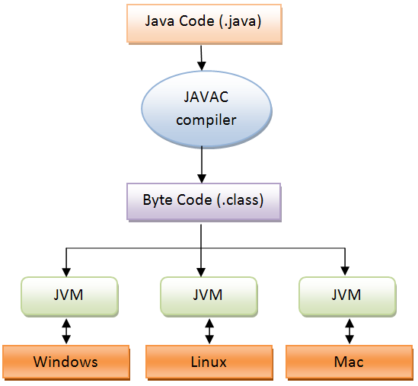

THE JAVA PROGRAMMING LANGUAGE:

The Java programming language is a high-level language that can be characterized by all of the following buzzwords:
- Simple
- Architecture neutral
- Object oriented
- Portable
- Distributed
- High performance
- Interpreted
- Multithreaded
- Robust
- Dynamic
- Secure
Applications are standalone programs, such as the Hot Java browser. Applets are similar to applications, but they don't run standalone. Instead, applets adhere to a set of conventions that lets them run within a Java-compatible browser.
With most programming languages, you either compile or interpret a program so that you can run it on your computer. The Java programming language is unusual in that a program is both compiled and interpreted. With the compiler, first you translate a program into an intermediate language called Java byte codes —the platform-independent codes interpreted by the interpreter on the Java platform.
JAVA - CONTROL FLOW STATEMENTS:
The Java programming language provides several control flow statements,
- looping - while, do-while , for
- decision - making if-else, switch-case
- exception - handling try-catch-finally, throw
- branching - break, continue, label:, return

They can be used to,
- conditionally execute statements,
- to repeatedly execute a block of statements,
- and to otherwise change the normal, sequential flow of control.
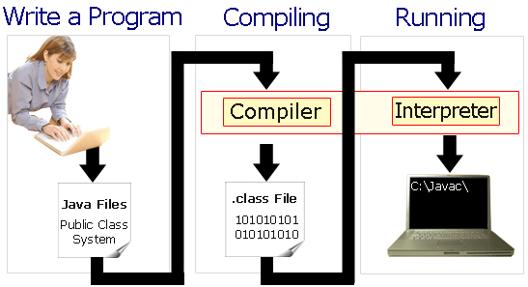

The interpreter parses and runs each Java byte code instruction on the computer. Compilation happens just once; interpretation occurs each time the program is executed. The following figure illustrates how this works. You can think of Java byte codes as the machine code instructions for the Java Virtual Machine (Java VM). Every Java interpreter, whether it’s a development tool or a Web browser that can run applets, is an implementation of the Java VM. Java byte codes help make “write once, run anywhere” possible. You can compile your program into byte codes on any platform that has a java compiler. The byte codes can then be run on any implementation of the java vm. That means that as long as a computer has a java vm, the same program written in the java programming language can run on windows 2000, a Solaris workstation, or on an imac.

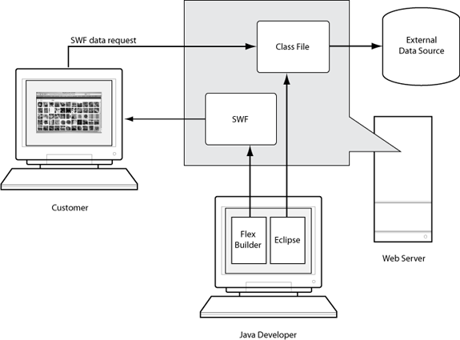

THE JAVA PLATFORM:
A platform is the hardware or software environment in which a program runs. We’ve already mentioned some of the most popular platforms like Windows 2000, Linux, Solaris, and MacOS. Most platforms can be described as a combination of the operating system and hardware. The Java platform differs from most other platforms in that it’s a software-only platform that runs on top of other hardware-based platforms.
The Java platform has two components:
- The Java Virtual Machine (Java VM)
- The Java Application Programming Interface (Java API)
You’ve already been introduced to the Java VM. It’s the base for the Java platform and is ported onto various hardware-based platforms. The Java API is a large collection of ready-made software components that provide many useful capabilities, such as graphical user interface (GUI) widgets. The Java API is grouped into libraries of related classes and interfaces; these libraries are known as packages.
The next section, What Can Java Technology Do? Highlights what functionality some of the packages in the Java API provide. The following figure depicts a program that’s running on the Java platform. As the figure shows. The Java API and the virtual machine insulate the program from the hardware.

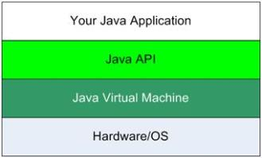
Native code is code that after you compile it, the compiled code runs on a specific hardware platform.
As a platform-independent environment, the Java platform can be a bit slower than native code. However, smart compilers, well-tuned interpreters, and just-in-time byte code compilers can bring performance close to that of native code without threatening portability.

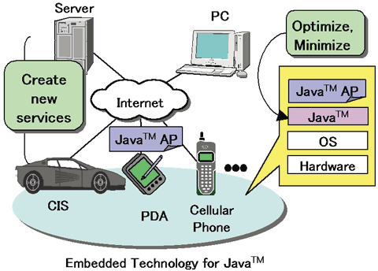

JAVA TECHNOLOGY:
We can’t promise you fame, fortune, or even a job if you learn the Java programming language. Still, it is likely to make your programs better and requires less effort than other languages. We believe that Java technology will help you do the following:
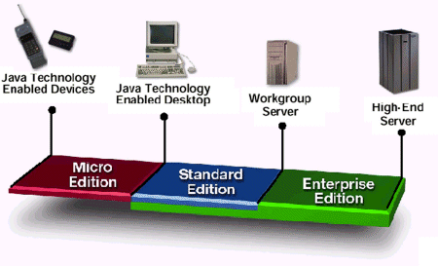

- Get started quickly: Although the Java programming language is a powerful object-oriented language, it’s easy to learn, especially for programmers already familiar with C or C++.
- Write less code: Comparisons of program metrics (class counts, method counts, and so on) suggest that a program written in the Java programming language can be four times smaller than the same program in C++.
- Write better code: The Java programming language encourages good coding practices, and its garbage collection helps you avoid memory leaks. Its object orientation, its JavaBeans component architecture, and its wide-ranging, easily extendible API let you reuse other people’s tested code and introduce fewer bugs.
- Develop programs more quickly: Your development time may be as much as twice as fast versus writing the same program in C++. Why? You write fewer lines of code and it is a simpler programming language than C++.
- Avoid platform dependencies with 100% Pure Java: You can keep your program portable by avoiding the use of libraries written in other languages. The 100% Pure JavaTM Product Certification Program has a repository of historical process manuals, white papers, brochures, and similar materials online.
- Write once, run anywhere: Because 100% Pure Java programs are compiled into machine-independent byte codes, they run consistently on any Java platform.
- Distribute software more easily: You can upgrade applets easily from a central server. Applets take advantage of the feature of allowing new classes to be loaded “on the fly,” without recompiling the entire program.

NETBEANS:

The NetBeans IDE is an award-winning Integrated Development Environment available for Windows, Mac, Linux, and Solaris. The NetBeans project consists of an open-source IDE and an application platform which enable developers to rapidly create web, enterprise, desktop, and mobile applications using the Java platform, as well as PHP, JavaScript and Ajax, Ruby and Ruby on Rails, Groovy, and C/C++.
NetBeans is an open-source integrated development environment (IDE) for developing with Java, PHP, C++, and other programming languages. NetBeans is also referred to as a platform of modular components used for developing Java desktop applications. NetBeans uses components, also known as modules, to enable software development. NetBeans dynamically installs modules and allows users to download updated features and digitally authenticated upgrades.
NetBeans IDE modules include NetBeans Profiler, a Graphical User Interface (GUI) design tool, and NetBeans JavaScript Editor. NetBeans framework reusability simplifies Java Swing desktop application development, which provides platform extension capabilities to third-party developers.

NETBEANS PLATFORM:
The NetBeans Platform is a reusable framework for simplifying the development of Java Swing desktop applications. The NetBeans IDE bundle for Java SE contains what is needed to start developing NetBeans plug-in and NetBeans Platform based applications; no additional SDK is required. Applications can install modules dynamically. Any application can include the Update Center module to allow users of the application to download digitally assigned upgrades and new features directly into the running application. Reinstalling an upgrade or a new release does not force users to download the entire application again. The platform offers reusable services common to desktop applications, allowing developers to focus on the logic specific to their application. Among the features of the platform are:
- User interface management (e.g. menus and toolbars)
- User settings management
- Storage management (saving and loading any kind of data)
- Window management
- Wizard framework (supports step-by-step dialogs)
- NetBeans Visual Library
- Integrated Development Tools

NETBEANS IDE:
NetBeans IDE is an open source integrated development environment. NetBeans IDE supports development of all Java application types out of the box. Among other features are an Ant-based project system, Maven support, refactoring, and version control.
MODULARITY:
All the functions of the IDE are provided by modules. Each module provides a well defined function, such as support for the Java language editing, or support for the CVS versioning system, and SVN. NetBeans contains all the modules needed for Java development in a single download, allowing the user to start working immediately. Modules also allow NetBeans to be extended. New features, such as support for other programming languages, can be added by installing additional modules.

NETBEANS PROFILER:
The NetBeans Profiler is a tool for the monitoring of Java applications: It helps developers find memory leaks and optimize speed. Formerly downloaded separately, it is integrated into the core IDE since version 6.0. The is based on a Sun Laboratories research project that was named JFluid. That research uncovered specific techniques that can be used to lower the overhead of profiling a Java application. One of those techniques is dynamic byte code instrumentation, which is particularly useful for profiling large Java applications. Using dynamic byte code instrumentation and additional algorithms, the NetBeans Profiler is able to obtain runtime information on applications that are too large or complex for other profilers. NetBeans also support Profiling Points that let you profile precise points of execution and measure execution time.

NETBEANS – ADVANTAGES:

GUI:
The major requirement of today’s developers is to have a good User Interface for their users. They can provide whatever functionality they need but it the GUI that lets the user better knows the existence of that particular functionality and its easier for them to click.
Database Integration:
Database based program developers know how hard it is to interface your back-end database to your front-end program. This is where net beans packs the punch by providing you a CRUD (create, Read, Update, Delete) application shell.
JPCAP:
Intrusion detection systems serve three essential security functions: they monitor, detect, and respond to unauthorized activity by company insiders and outsider intrusion. Intrusion detection systems use policies to define certain events that, if detected will issue an alert. In other words, if a particular event is considered to constitute a security incident, an alert will be issued if that event is detected. Certain intrusion detection systems have the capability of sending out alerts, so that the administrator of the IDS will receive a notification of a possible security incident in the form of a page, email, or SNMP trap. Many intrusion detection systems not only recognize a particular incident and issue an appropriate alert, they also respond automatically to the event. Such a response might include logging off a user, disabling a user account, and launching of scripts.

Number of hacking and intrusion incidents is increasing alarmingly each year as new Technology rolls out. Unfortunately in today’s digitally connected world, there is no place to hide. DNS, Snooker, Newsgroups, web site trawling, e-mail properties etc. are just some of the many ways in which you can be found. In this research work, it has designed and build an Intrusion Detection System (IDS) that implement pre-defined algorithms for identifying the attacks over a network. The Java programming language is used to develop the system, JPCap must be used to provide access to the win cap. The packets in the network are captured online i.e., as they come on the interface of the network. The IDS is designed to provide the basic detection techniques so as to secure the systems present in the networks that are directly or indirectly connected to the Internet.
Jpcap is an open source library for capturing and sending network packets from Java applications. It provides facilities to:
- Capture raw packets live from the wire.
- Save captured packets to an offline file, and read captured packets from an offline file.
- Automatically identify packet types and generate corresponding Java objects (for Ethernet, IPv4, IPv6, ARP/RARP, TCP, UDP, and ICMPv4 packets).
- Filter the packets according to user-specified rules before dispatching them to the application.
- send raw packets to the network
Jpcap is based on libpcap/winpcap, and is implemented in C and Java. Jpcap has been tested on Microsoft Windows (98/2000/XP/Vista), Linux (Fedora, Ubuntu), Mac OS X (Darwin), FreeBSD, and Solaris.
Jpcap can be used to develop many kinds of network applications, including (but not limited to):
- network and protocol analyzers
- network monitors
- traffic loggers
- traffic generators
- user-level bridges and routers
- network intrusion detection systems (NIDS)
- network scanners
- security tools
Jpcap captures and sends packets independently from the host protocols (e.g., TCP/IP). This means that Jpcap does not (cannot) block, filter or manipulate the traffic generated by other programs on the same machine: it simply "sniffs" the packets that transit on the wire. Therefore, it does not provide the appropriate support for applications like traffic shapers, QoS schedulers and personal firewalls.
REFERENCE:
      - H. Achi, A. Hellany & M. Nagrial. Network Security Approach for Digital Forensics Analysis 2008 IEEE
      - Karen Kent, Suzanne Chevaller, Tim Grance, Hung Dang. Guide to Integrating Forensic Techniques into incident response.
      - Eoghan Casey Network traffic as a source of evidence: Tool strengths, weaknesses, and future needs; Digital investigation Journal December 2003.
      - Stephen K. Brannon, and Thomas Song Computer Forensics: Digital Forensic Analysis Methodology. Compter Forensics Journal January 2008 Volume 56
      - Dava Klieiman , Kevin,Timothy, Micheil Cross The official CHFI Study guide for forensic Investigators.
      - Brian Carrier . File system Forensic Analysis. Publisher addison Wesley Professional .publication Date. March 17, 2005
- Natarajan Meghanathan, Sumanth Reddy Allam and Loretta A.Tools And Techniques For Network Forensics, USA International Journal of Network Security & Its Applications (IJNSA), Vol .1, No.1,April 2009.
- Cheong Kaiwee. Analysis of Hidden Data in NTFS File system. whitepaper
- Mamoun, Alazab, Sitalakshmi Venktraman, Paul Watters. Effective Digital forensic Analysis of the NTFS Disk Image. Ubicc Journal, vol 4.
- Ali Reza Arasteh, Mourad Debbabi, Assaad Sakha, Mohamed Saleh Analyzing multiple logs for forensic evidence Digital investigations Journal Science Direct.
- Vitoras Justickis Criminal Datamining, chapter 33 of Security handbook of electronic Security and Digital Forensics.
- Chen, H., Chung, W., Qin, Y., Chau, M., Xu, J. J., Wang, G., Zheng, R.,Atabakhsh, H. (2003). Crime Data Mining: An Overview and Case Studies. ACM International Conference Proceeding Series; Vol. 130, 1-5.
- K. Kent, S. Chevaller, T. Grance and H. Dang, “Guide to Integrating Forensic Techniques into Incident Response,” NIST SP800-86 Notes, 2006.

- S. K. Brannon and T. Song, “Computer Forensics: Digital Forensic Analysis Methodology,” Computer Forensics Journal, Vol. 56, No. 1, 2008, pp. 1-8.
- D. Klieiman, K. Timothy and M. Cross, “The Official CHFI Study Guide for Forensic Investigators,” 2007.
- B. Carrier, “File System Forensic Analysis,” Addison Wesley Professional, 2005.
- C. Kaiwee, “Analysis of Hidden Data in NTFS File Sys-tem,” Whitepaper.
- M. Alazab, S. Venktraman and P. Watters, “Effective Digital Forensic Analysis of the NTFS Disk Image,” Ubiquitous Computing and Communication Journal, Vol. 4, No. 3, 2009, pp. 551-558.
- N. Meghanathan, S. R. Allam and L. A. Moore, “Tools and Techniques for Network Forensics,” International Journal of Network Security & Its Applications, Vol. 1, No. 1, 2009, pp. 14-25.
- E. Casey, “Network Traffic as a Source of Evidence: Tool Strengths, Weaknesses, and Future Needs,” Journal of Digital Investigation, Vol. 1, No. 1, 2004, pp. 28-43.

